**Hotel Front Desk Task –**

There are still a lot of optimizations to do, and lot more styling is necessary. But the core functionality is done.

Initially on starting the application we will see this page as default.

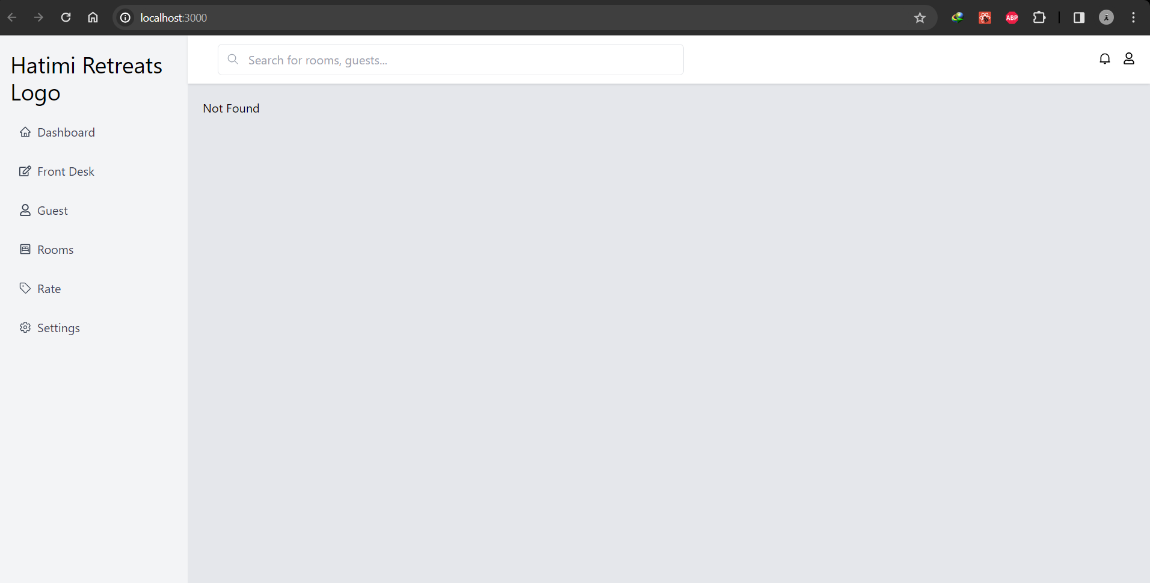

**Dashboard Screen** -

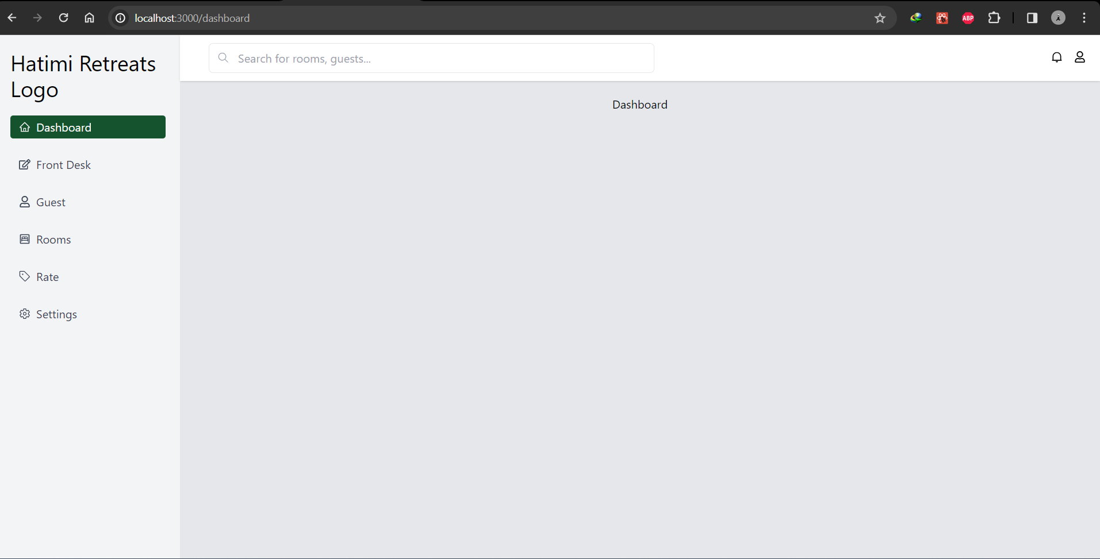

**Front Desk Screen** – Initially Standard Rooms are displayed and the reservations are displayed along with the available rooms count. Also deluxe is rendered below with available rooms count.

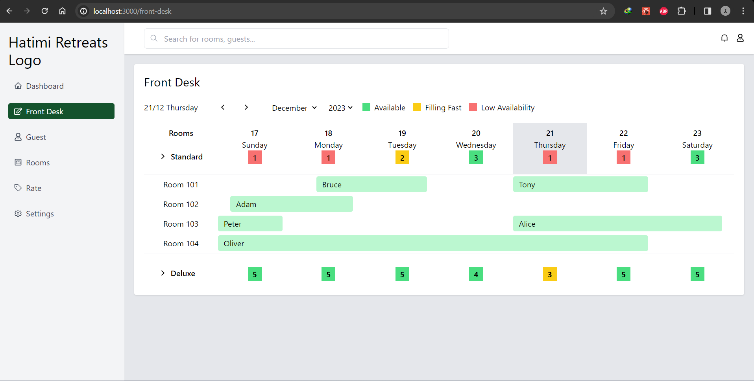

We can select Deluxe to see the reservations.

